**Self-Assessment 2-5**

5. Draw the circuit that implements each of the following expressions:

1. ab + b'c + cd
2. (a'+b)(b'+c')(c'+d')

a.

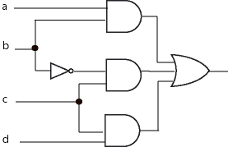

b.

